REVERSE OF DIGIT

HARIRAJ G

230701104

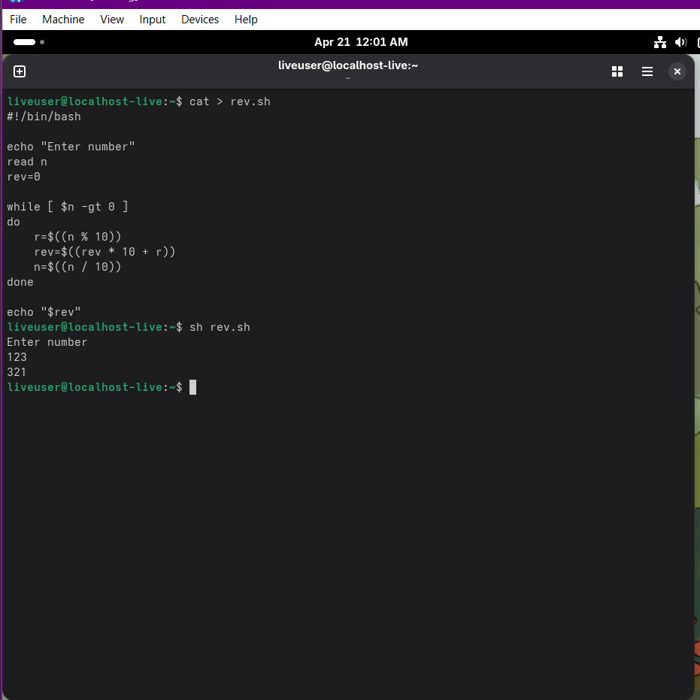

FIBBNONACCI SERIES

